**Exercises on Grid Layout**

**Exercise 1: Basic Grid Setup**

**Exercise:** Create a simple 3x3 grid layout where each cell is evenly spaced and has a border. Each cell should contain image and text indicating its position as shown in the below pic.

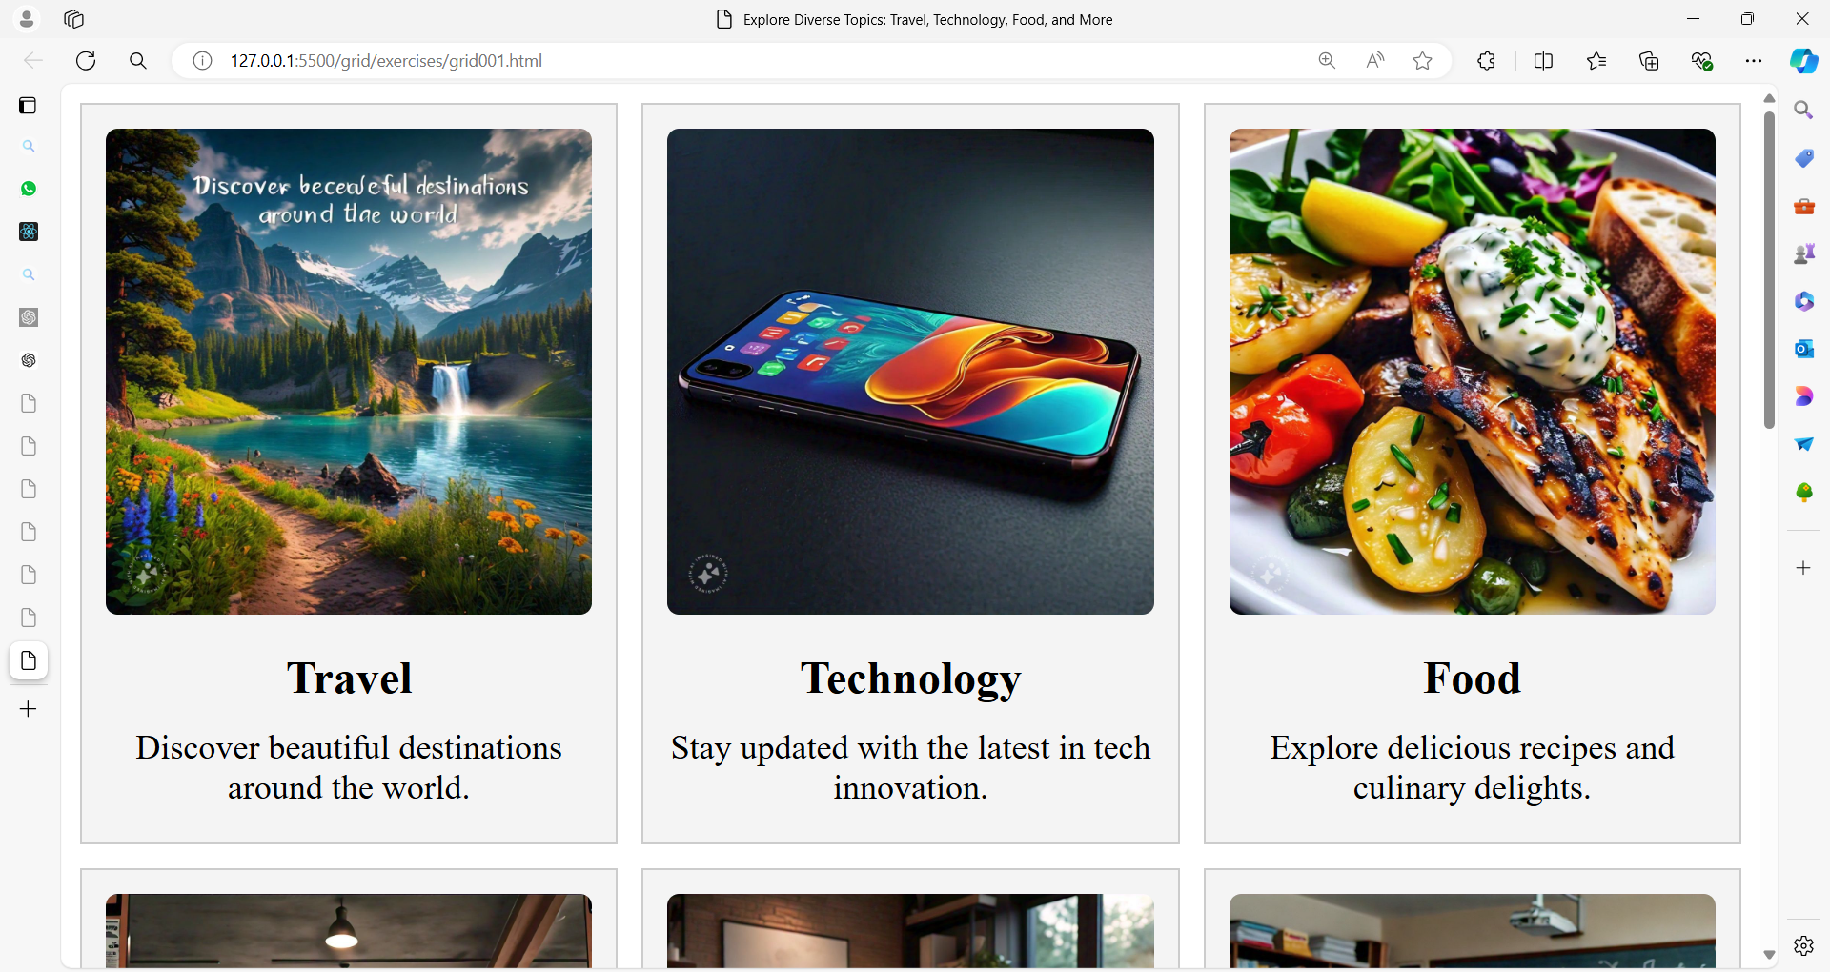

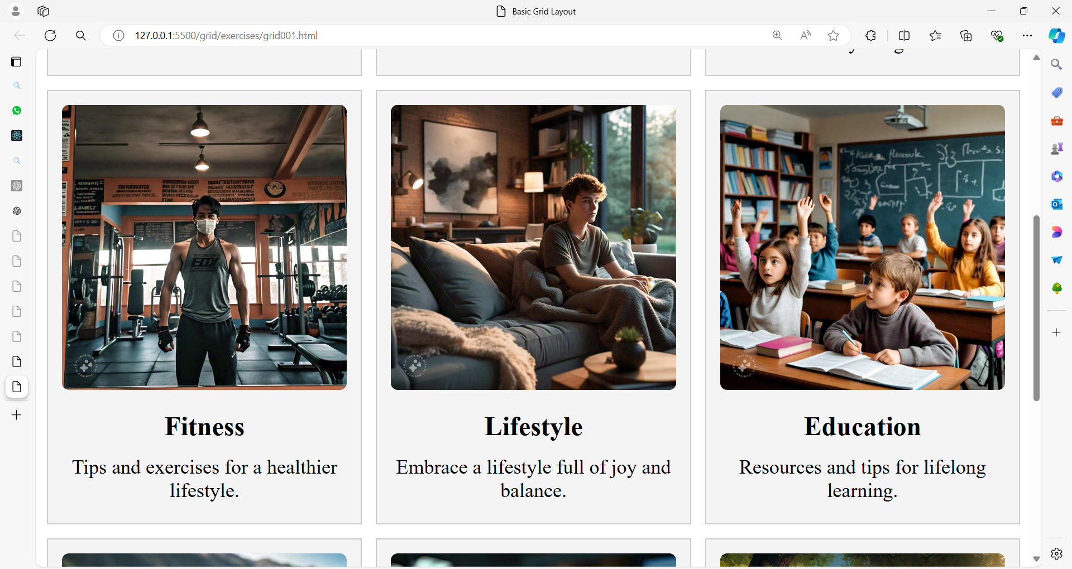

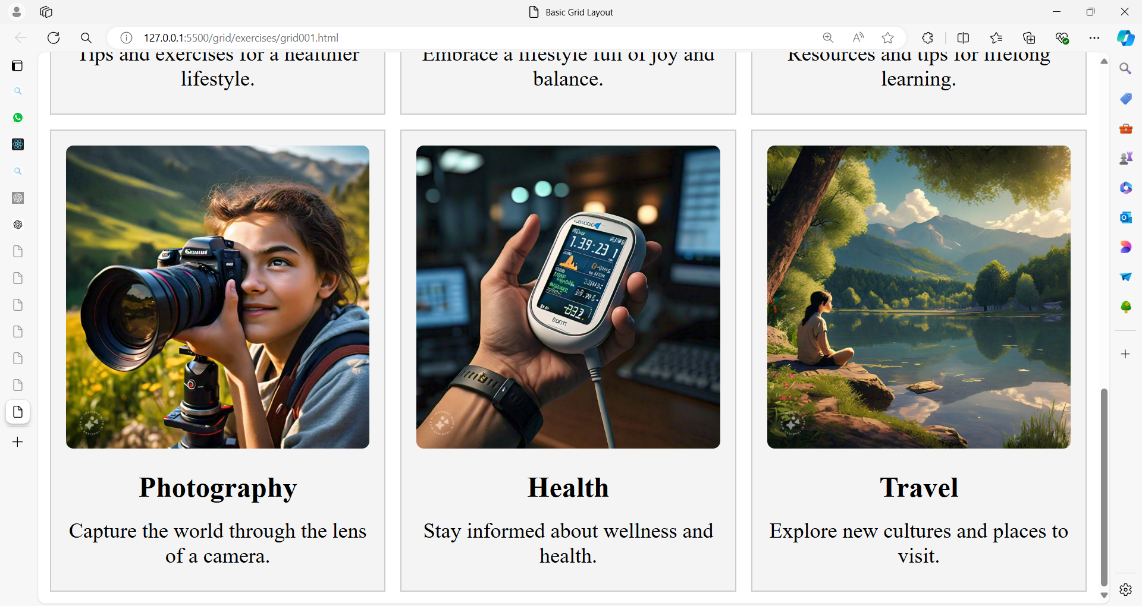

**Exercise 2: Asymmetric Grid Layout**

**Exercise:** Create a grid layout with three columns and two rows. The first row should have a full-width cell that spans all three columns, and the second row should have three equally-sized cells.

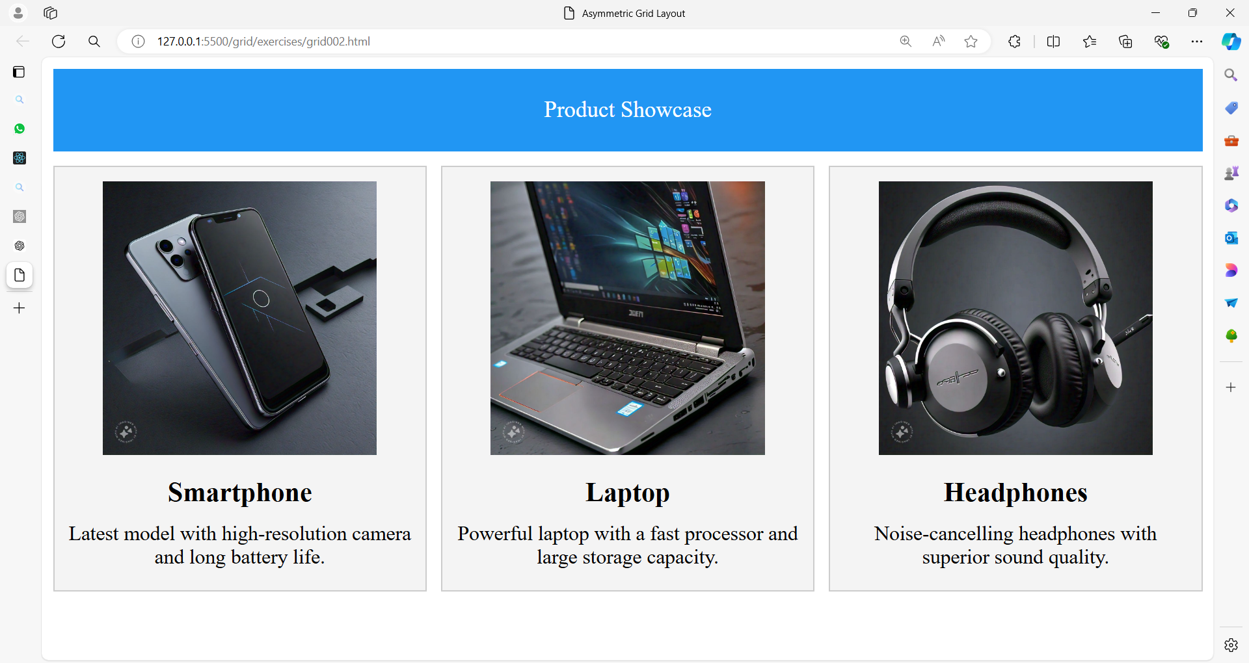

**Exercise 3: Nested Grid Layout**

**Exercise:** Create a grid layout where the main grid has two columns. The first column contains a nested grid with two rows and two columns. The second column contains a single cell that spans both rows of the nested grid.

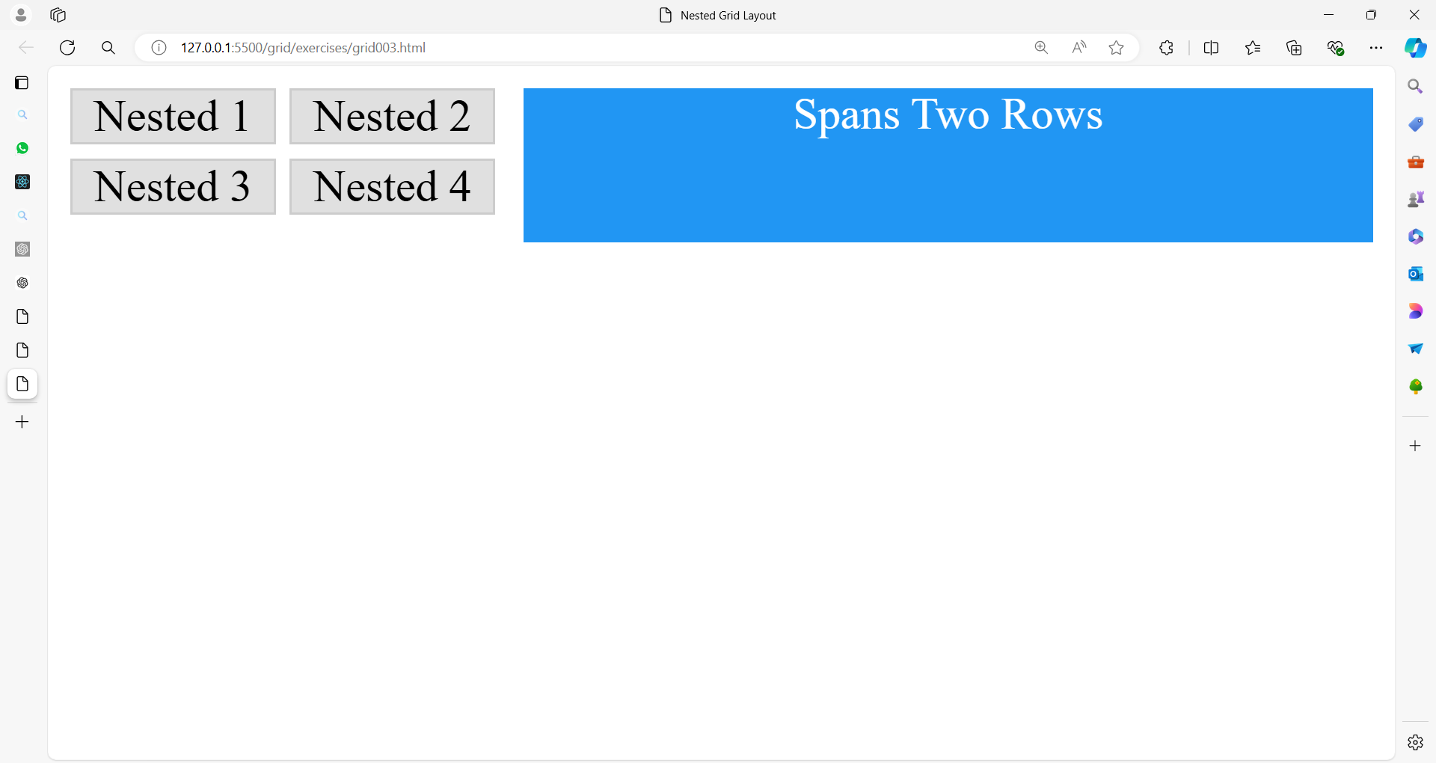

**Exercise 4: Responsive Grid Layout**

**Exercise:** Create a responsive grid layout with 4 columns on large screens, 2 columns on medium screens, and 1 column on small screens. Use media queries to adjust the layout.

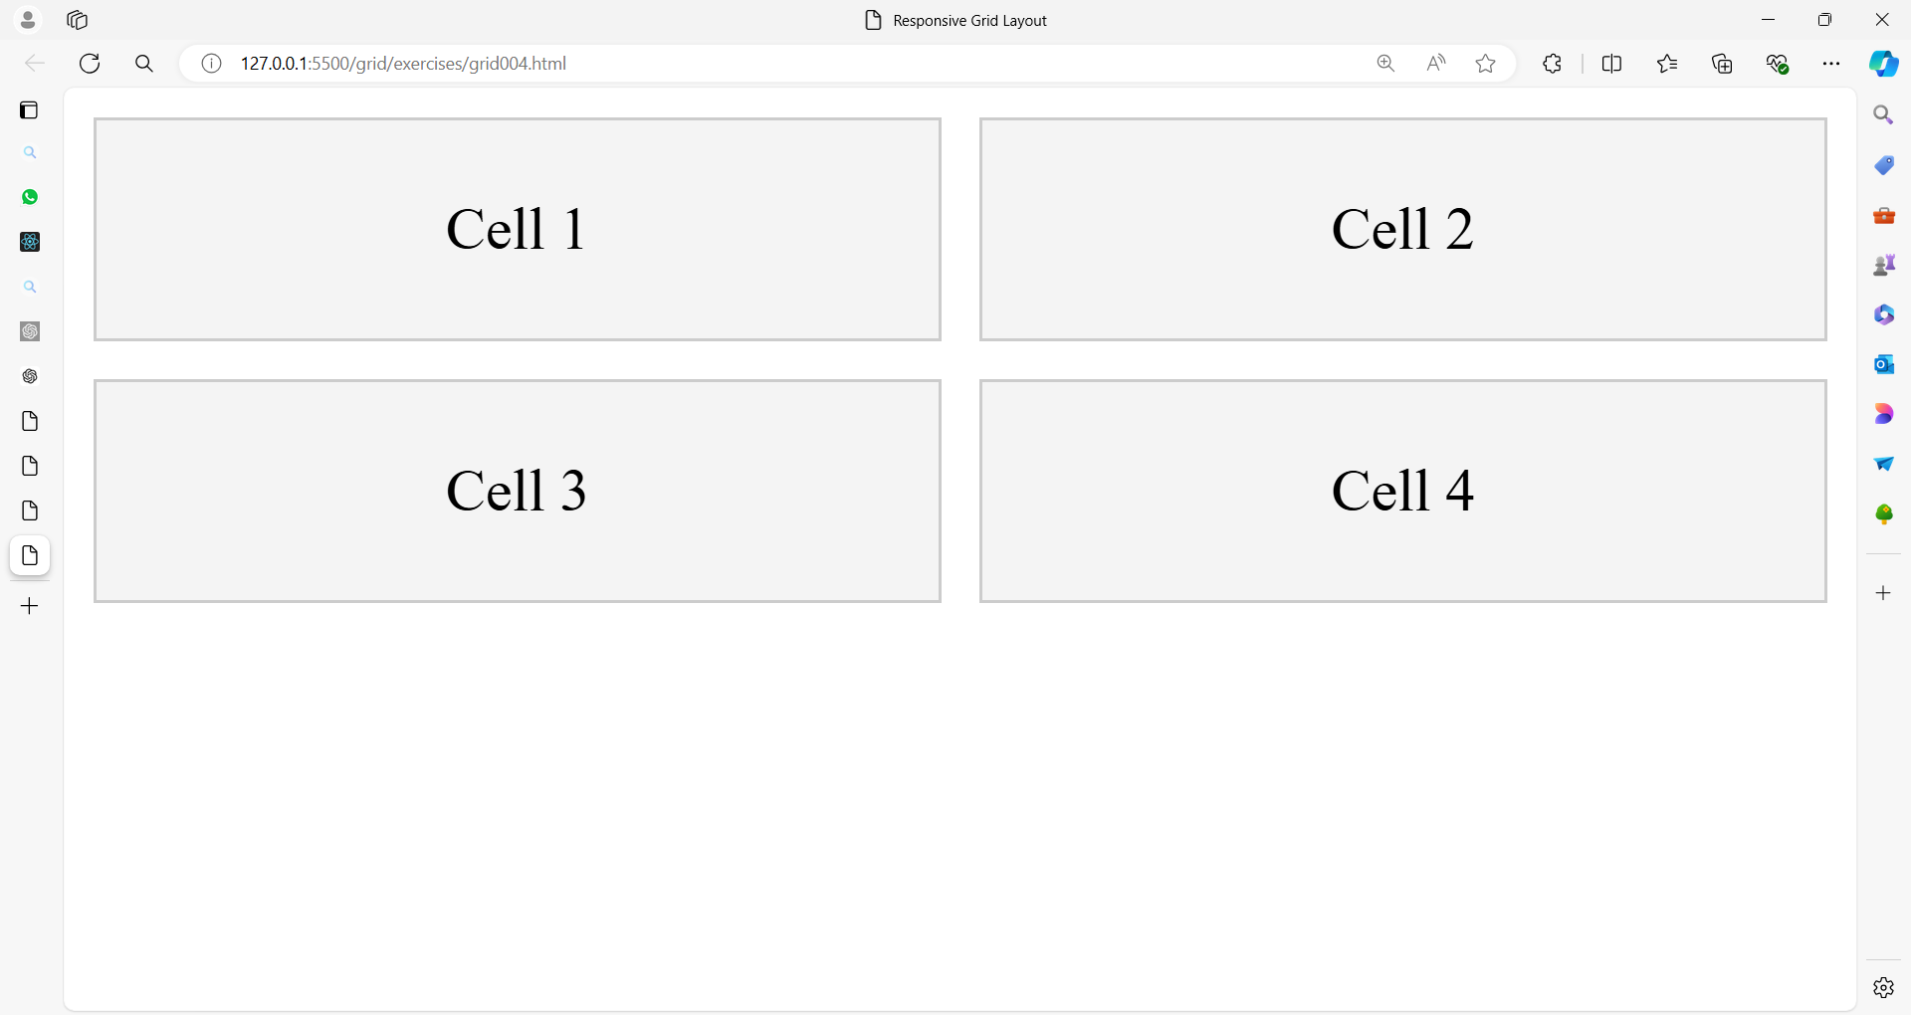

**Exercise 5: Grid with Named Areas**

**Exercise:** Create a grid layout with named areas. The layout should have a header, a sidebar, a main content area, and a footer.

